St Martin’s Low Marple Heritage Trust

Eve in the Gallery
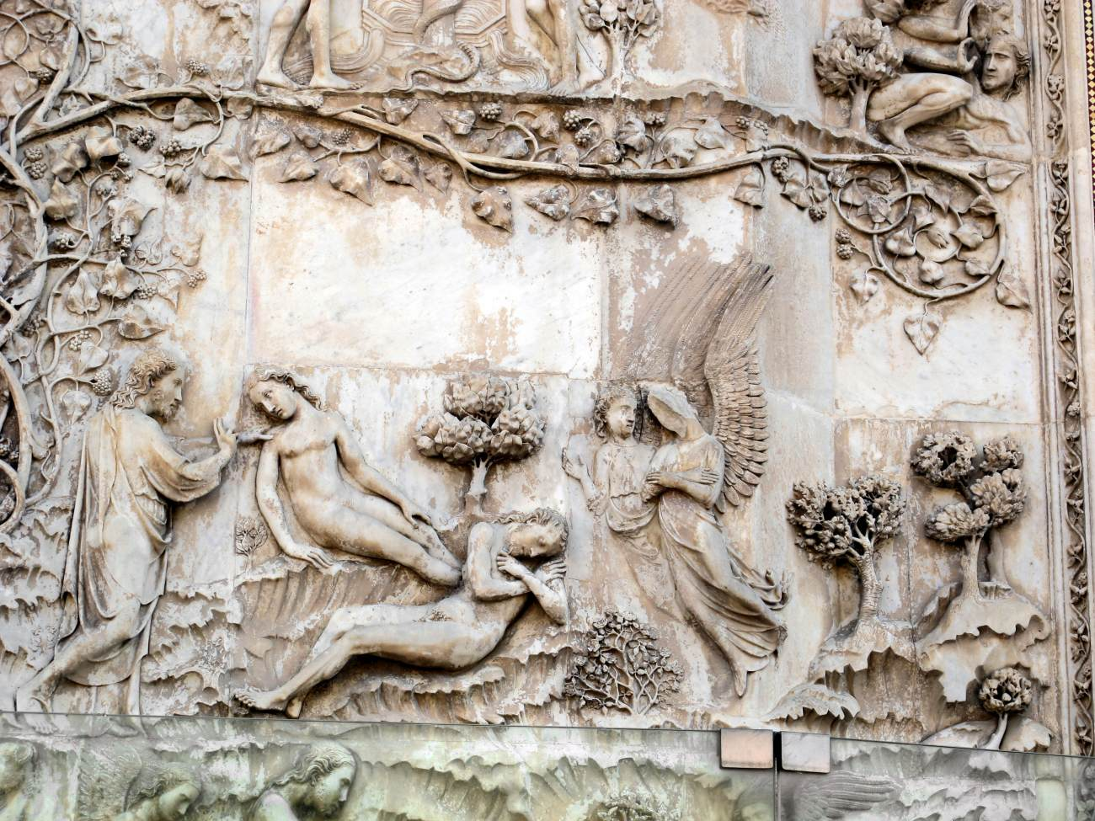
Relief by Lorenzo Maitoni in Orvieto cathedral, Italy

Eve is recognised within some of the world’s major
religions as the wife of Adam and mother of mankind.
Because of this, she has been well represented in Art
throughout the centuries. In this talk, Ann Jackson,
an experienced guide at Manchester Art Gallery,
shows some of the more surprising places where she
can be found, as well as more traditional depictions.

Saturday 13 June 2026, 2.30 – 4.00, with tea
Admission free, donations welcomed
St Martin’s Church Hall, Brabyns Brow, Marple
Next to Marple train station, and bus stops to and from Stockport (383, 384)
Parking: nearby paying carparks; or allow time to find free space in the vicinity

